Cairo University SEM – team 2

Faculty of Engineering

Computer Engineering Department

CMP2020

*Introduction to Database Systems*

***Code Courses***

ER Diagram Report

Team Number #2

**Team Members:**

|  |  |  |
| --- | --- | --- |
| Name | Section | BN |
| Ahmed Osama Helmy | 1 | 5 |
| Aliaa Gheis | 1 | 28 |
| Ahmed Abdelatty | 1 | 10 |
| Mennatallah Ahmed | 2 | 26 |

**Contact info:**

Mennatallah Ahmed: [mennaahmed0701@gmail.com](mailto:mennaahmed0701@gmail.com)

Ahmed Abdelatty: [ahmed.allah01@eng-st.cu.edu.eg](mailto:ahmed.allah01@eng-st.cu.edu.eg)

Aliaa Gheis: [aliaagheis@gmail.com](mailto:aliaagheis@gmail.com)

Ahmed Osama Helmy: [ahmed.osama1982002@gmail.com](mailto:ahmed.osama1982002@gmail.com)

27/10/2022

**ERR Entities with attributes:**

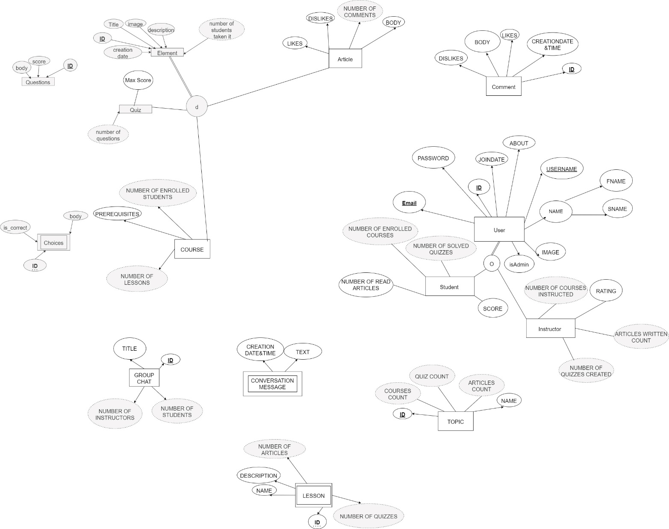

**ERR Entities with relationships:**

